

COSHH ASSESSMENT SHEET
Date of Assessment: 04.12.2025 Assessment No: CA 17 Assessor: Daniel Looney
Overall Assessment Rating of Risk [ √ ] Low [√ ] Medium [ ] High [ ]

Work Activity: |  |  |  |  |  |  |  |  |  |  | Detergent for use on motor vehicles
Persons at Risk: |  |  |  | User [√] Colleagues [√] Contractors [ ] Public [ ] Others [ ]
Name of Hazardous Substance: |  |  |  |  | AUTOGLYM No 19A PSV Fleetclean
Manufacturer (address/tele no): |  |  |  |  | AutoGlym Works Road, Letchworth, Herts, SG6 1LU
SDS Version: |  |  |  |  | 12
Supplier (address/tele no): |  |  |  |  | 01462 677766
Hazard data sheet attached: |  |  |  |  | Yes [ √ ] No [ ]
Description/colour: |  |  |  |  | Green
 | Container size in litres/kg |  |  |  | 20  litre/kg |  |  | 10  litre/kg |  |  |  | 5 litre/kg |  |  | >litre/kg |  | < litre/kg |  | Other
 | (tick as appropriate) |  |  |  | √
HAZARD (tick all that apply)
 | 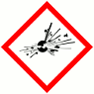 | 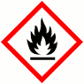 | 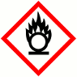 |  |  |  | 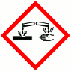 |  | 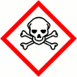 |  |  |  | 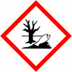 |  |  |  | 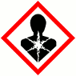 |  | 
 | Explosive (Symbol: exploding bomb) | Flammable (Symbol: flame) | Oxidising (Symbol: flame over circle) |  |  |  | Corrosive (Symbol: Corrosion) |  | Acute toxicity (Symbol: Skull and crossbones) |  |  |  | Hazardous to the environment (Symbol: Dead tree and fish) |  | Health hazard/Hazard ous to the ozone layer (Symbol: Exclamation mark) |  | Serious health hazard (Symbol: health hazard) |  | Gas under pressure (Symbol: Gas cylinder)
 |  |  |  |  |  |  |  |  |  |  |  |  |  |  | √
Known exposure levels:  W.E.L. (where applicable) |  |  |  |  |  | NA
Likely route of entry to body:  (tick all that apply) |  |  |  |  |  | Inhaled |  |  |  | Ingested |  |  |  | Absorbed by skin |  | Eyes |  | Other
 |  |  |  |  |  |  |  |  |  |  |  |  |  |  |  | √
Areas of use/exposure: |  |  |  |  |  | Bus washes

CONTROL MEASURES
Can the exposure/use be eliminated or substituted? | (tick as appropriate) | Yes | No √
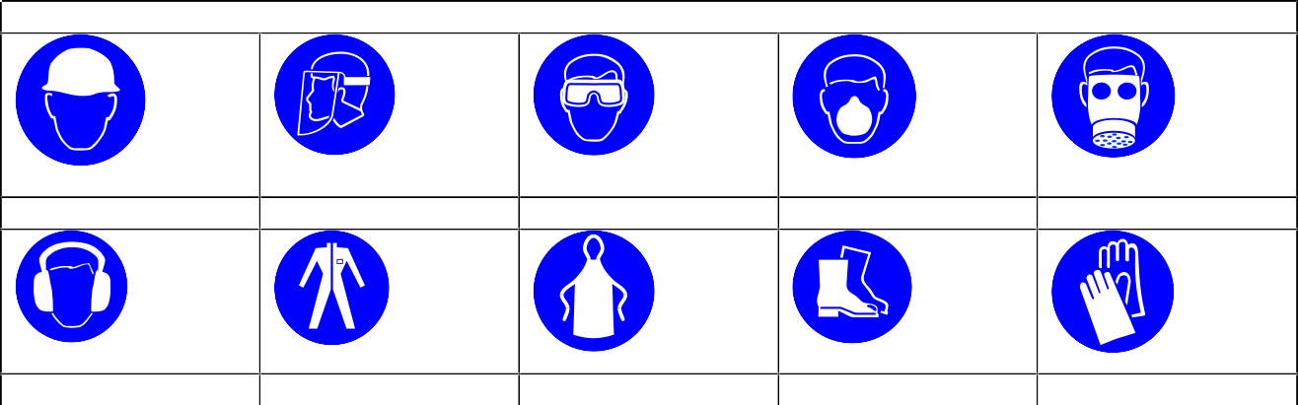
PERSONAL PROTECTIVE EQUIPMENT REQUIREMENT. (tick as appropriate)
Hard Hats
Face Protection
Eye Protection: √
Dust Mask
Respirator
Ear Protection
Overalls
Apron
Foot Protection
Gloves: √
Is monitoring required? | (tick as appropriate) |  |  | Yes |  | No √
Local exhaust ventilation required? | (tick as appropriate) |  |  | Yes |  | No √
Documented working method available on safe use and  handling? | (tick as appropriate) |  |  | Yes √ |  | No
Storage: | Maximum amount to be stored on site | Secure store out of reach of service  users and children | Store to be well ventilated |  | Separate storage facility available or required |  | Other
(tick all that apply) |  | √ | √
Method of use. | Use undiluted | Use diluted | Wash hands after use |  | Do not mix with other products |  | Special precaution s
(tick all that apply) |  | √ | √ |  | √
State any special/storage requirements or other precautions not listed above:
Suitable extinguishing media: Not flammable. Use media suitable for surrounding fire

Type of PPE & Model Nos |  |  | Type of PPE & Model Nos
Safety Glasses EN166 – if risk of splashing |  |  | Gloves – EN374 Chemical resistant - if prolonged exposure
Who orders PPE? | Area Manager
EMERGENCY CONTROLS
First Aid: Eyes |  | Bathe the eye with running water for 15 minutes. Transfer to hospital for specialist examination.
Skin |  | Remove all contaminated clothes and footwear immediately unless stuck to skin. Wash immediately with plenty of soap and water.
Inhalation |  | Remove casualty from exposure ensuring one’s own safety whilst doing so.
Ingestion |  | Wash out mouth with water. Do not induce vomiting. If Conscious, give half a litre of water to drink immediately. Consult a doctor
Dealing with spillage: |  | Absorb into dry earth or sand. Transfer to a closable, labelled salvage container for disposal by an appropriate method
Disposal: |  | Empty containers to be collected as instructed by area manager
Precautions already in place: |  | PPE, Method statements, Induction and on-going training
Advice available from? |  | AUTOGLYM

2

