

COSHH ASSESSMENT SHEET
Date of Assessment: 04.02.2025 Assessment No: CA 20 Assessor: Daniel Looney
Overall Assessment Rating of Risk [ √ ] Low [√ ] ] Medium [ ] High [ ]

Work Activity: |  |  |  |  |  |  |  |  |  |  | Cleaning
Persons at Risk: |  |  |  | User [√ ] Colleagues [√ ] Contractors [ ] Public [ ] Others [ ]
Name of Hazardous Substance: |  |  |  |  | Pureclean Bus Wash
Manufacturer (address/tele no): |  |  |  |  | Chela Ltd  68 Bilton Way EN3 7NH Enfield UK
SDS Version: |  |  |  |  | 1
Supplier (address/tele no): |  |  |  |  | 0208 8052150
Hazard data sheet attached: |  |  |  |  | Yes [√ ] No [ ]
Description/colour: |  |  |  |  | Pale yellow
 | Container size in litres/kg |  |  |  | 20  litre/kg |  |  | 10  litre/kg |  |  |  | 5 litre/kg |  |  | >litre/kg |  | < litre/kg |  | Other
 | (tick as appropriate) |  |  |  |  |  |  |  |  |  |  | √
HAZARD (tick all that apply) – NOT CLASSIFIED
 | 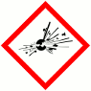 | 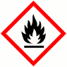 | 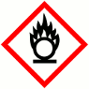 |  |  |  | 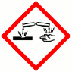 |  | 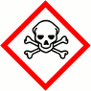 |  |  |  | 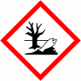 |  |  |  | 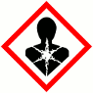 |  | 
 | Explosive (Symbol: exploding bomb) | Flammable (Symbol: flame) | Oxidising (Symbol: flame over circle) |  |  |  | Corrosive (Symbol: Corrosion) |  | Acute toxicity (Symbol: Skull and crossbones) |  |  |  | Hazardous to the environment (Symbol: Dead tree and fish) |  | Health hazard/Hazard ous to the ozone layer (Symbol: Exclamation mark) |  | Serious health hazard (Symbol: health hazard) |  | Gas under pressure (Symbol: Gas cylinder)
Known exposure levels:  W.E.L. (where applicable) |  |  |  |  |  | Not specified
Likely route of entry to body:  (tick all that apply) |  |  |  |  |  | Inhaled |  |  |  | Ingested |  |  |  | Absorbed by skin |  | Eyes |  | Other
 |  |  |  |  |  | √ |  |  |  |  |  |  |  | √ |  | √
Areas of use/exposure:

CONTROL MEASURES
Can the exposure/use be eliminated or substituted? | (tick as appropriate) | Yes | No √

Is monitoring required? | (tick as appropriate) |  |  | Yes |  | No √
Local exhaust ventilation required? | (tick as appropriate) |  |  | Yes |  | No √
Documented working method available on safe use and handling? | (tick as appropriate) |  |  | Yes √ |  | No
Storage: | Maximum amount to be stored on site | Secure store out of reach of service users and children | Store to be well ventilated |  | Separate storage facility available or required |  | Other
(tick all that apply) |  | √ | √
Method of use. | Use undiluted | Use diluted | Wash hands after use |  | Do not mix with other products |  | Special precautions
(tick all that apply) |  | √ | √ |  | √
State any special/storage requirements or other precautions not listed above:
Suitable fire extinguishing media: Water spray. Dry powder. Foam. Carbon dioxide
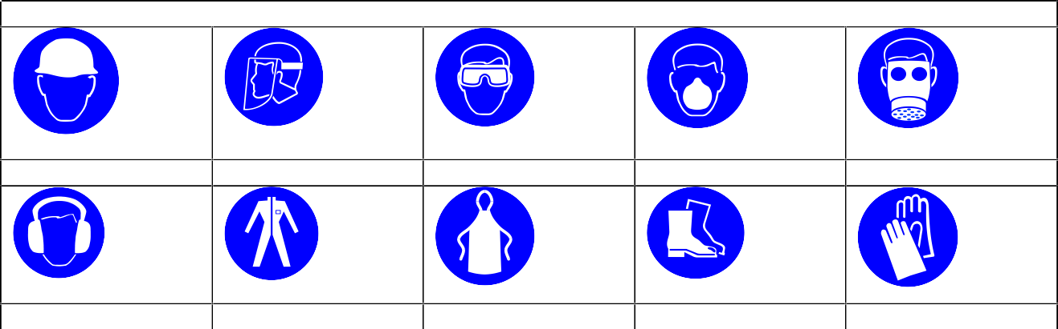
PERSONAL PROTECTIVE EQUIPMENT REQUIREMENT. (tick as appropriate)
Hard Hats
Face Protection
Eye Protection
Dust Mask
Respirator
Ear Protection
Overalls
Apron
Foot Protection
Gloves
Eye Protection √

Type of PPE & Model Nos |  |  | Type of PPE & Model Nos
Who orders PPE? | Area Manager
EMERGENCY CONTROLS
First Aid: Eyes |  | Rinse cautiously with water for several minutes
Skin |  | Wash skin immediately with plenty of water
Inhalation |  | NA when used as directed
Ingestion |  | Do not induce vomiting. Call poison centre if you feel unwell. f
Dealing with spillage: |  | Soak up spillage with absorbent material
Disposal: |  | Empty containers to be disposed using authorised hazardous waste contractor
Precautions already in place: |  | PPE, method statements, induction & on-going training
Advice available from? |  | Chela

2

